**Assignment-1**

**Name:** Saibalaji SM

**Reg no:**711119104051

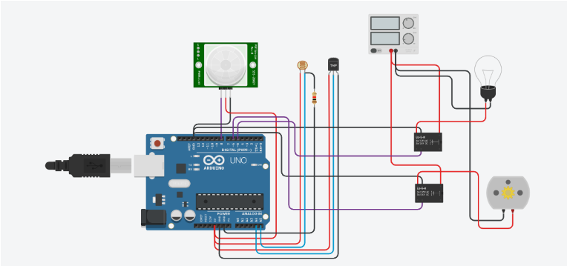**CIRCUIT DIAGRAM:**

Float x,y,z,temp;

void setup()

{ pinMode(8, INPUT);

pinMode(5, OUTPUT);

pinMode(6, OUTPUT);

pinMode(A5, INPUT);

pinMode(A4, INPUT);

Serial.begin(9600); }

void loop()

{ x= digitalRead(8);

y= analogRead(A5);

z=analogRead(A4);

Serial.println(x);

Serial.println(y);

Serial.println(z);

temp=(double)z/1024;

temp=temp *5;

temp=temp -0.5;

temp=temp *100;

if((x>0))

{

if ((y<550)&&(temp>30))

{ digitalWrite(5, HIGH); digitalWrite(6, HIGH);}

else

if((y<550)&&(temp<30))

{ digitalWrite(5, HIGH);

digitalWrite(6, LOW); } else

if((y>550)&&(temp>30))

{ digitalWrite(5, LOW);

digitalWrite(6, HIGH);}else

if((y>550)&&(temp<30))

{ digitalWrite(5,LOW); digitalWrite(6, LOW);

} } else

{ digitalWrite(5,LOW);

digitalWrite(6,LOW);

}

}